**DAY 3 - API INTEGRATION AND DATA MIGRATION**

Import data from api and send to sanity

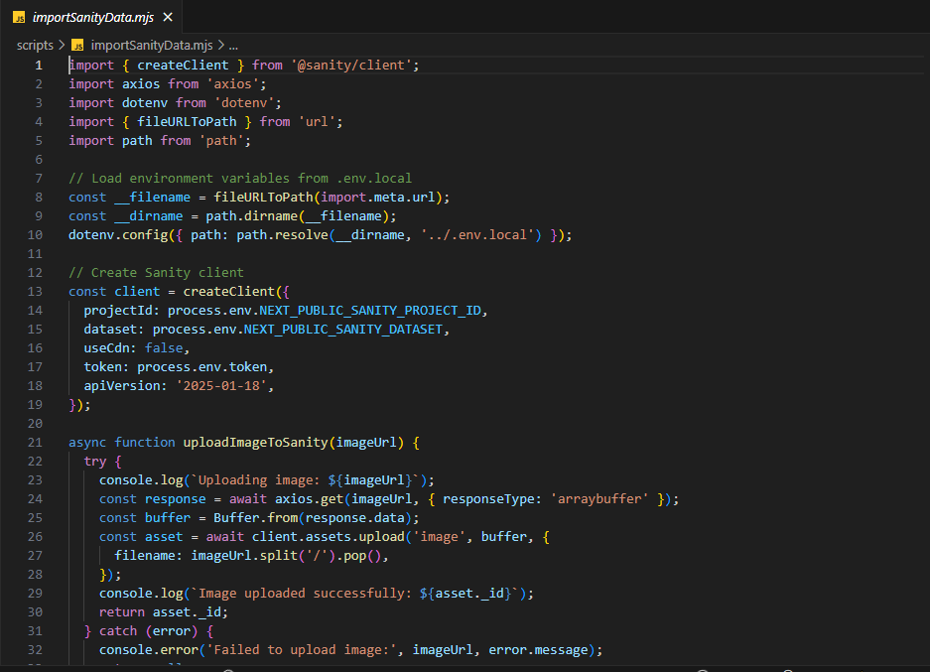

Here is successfully data send to sanity

